 | 15.2 Editors - Movie Clip Editor - Tool shelf
Table of content
Tool Shelf 1
Track Tab and Solve Tab in Tracking Mode 1
Annotation tab 1
Draw 1
Draw 1
Erase 2
Line 2
Poly 2
Stroke Placement 2
View 2
Cursor 2

Tool Shelf
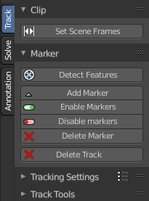
The Tool Shelf exists for the Tracking Mode in Clip submode. And for Mask mode.
In Tracking Mode it contains the tools to do the tracking. And in Mask Mode some mask tool functionality.
The submodes Graph and Dopesheet does not have a tool shelf. Here you can find a list of the tracks instead.
The content is differing, dependant of the mode you are in. Tracking mode has other tools than the Masking mode.

Track Tab and Solve Tab in Tracking Mode

The track tab contains the tools around the movie side of things. Markers, tracking etc.
The solve tab contains the tools around the scene side of things. Scene setup, camera motion, etc.

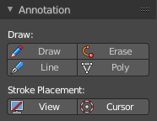
Annotation tab
The Annotation tab contains the usual Annotation tools to draw and erase strokes. The tools should be self explaining

Draw

Draw
Draw freehand strokes.

Erase
Erase strokes.

Line
Draw a line by clicking at a starting point and then at the end point.

Poly
Draw a polygon by clicking at the places where a corner should be.

Stroke Placement

View
Place the strokes relative to the view.

Cursor
Place the strokes relative to the cursor.

